Data Structures and Algorithms

# **Function**

Whenever there is a return statement being executed the function stops executing after the return statement is executed.

# **Recursion**

1. When a function call calls itself.
2. When a specified condition is met

**Example to understand point 1: -**

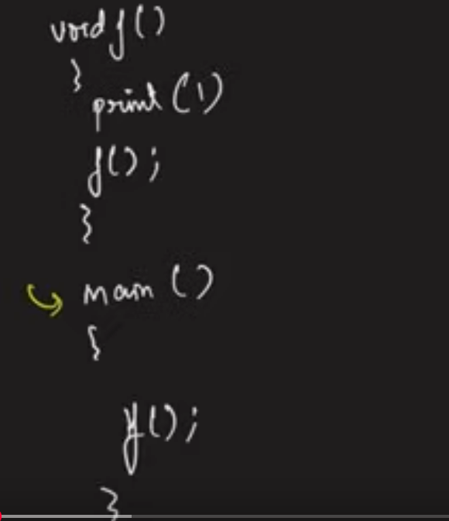

**Running of the program:**

1. Program comes to main i.e., the execution
2. Whenever a function is called it straight away goes and calls the function. In the above example function ‘f’ is called inside main, so it straight away goes and calls the function ‘f’.
3. The function ‘f’ executes the line `print(1)`. So, in the output screen 1 is printed.
4. After step 3, the next line is executed which states calling of the self-function ‘f’, which means it is calling the same function in memory.
5. The function ‘f’ executes the line `print(1)`. So, in the output screen 1 is printed.
6. After step 5, the next line is executed which states calling of the self-function ‘f’, which means it is calling the same function in memory. It goes on again and again everyday as there is no stop condition which says to stop calling the self again.
7. The above is an infinite recursion or non-ending recursion as there is no specified condition mentioned to stop it.
8. In the program run, it prints many 1’s and then it ran out of memory. This is called Stack Overflow.

**Example to understand point 2: -**

We will have a condition where we will stop calling the function that condition is know as base condition.

|  |  |
| --- | --- |
|  |  |



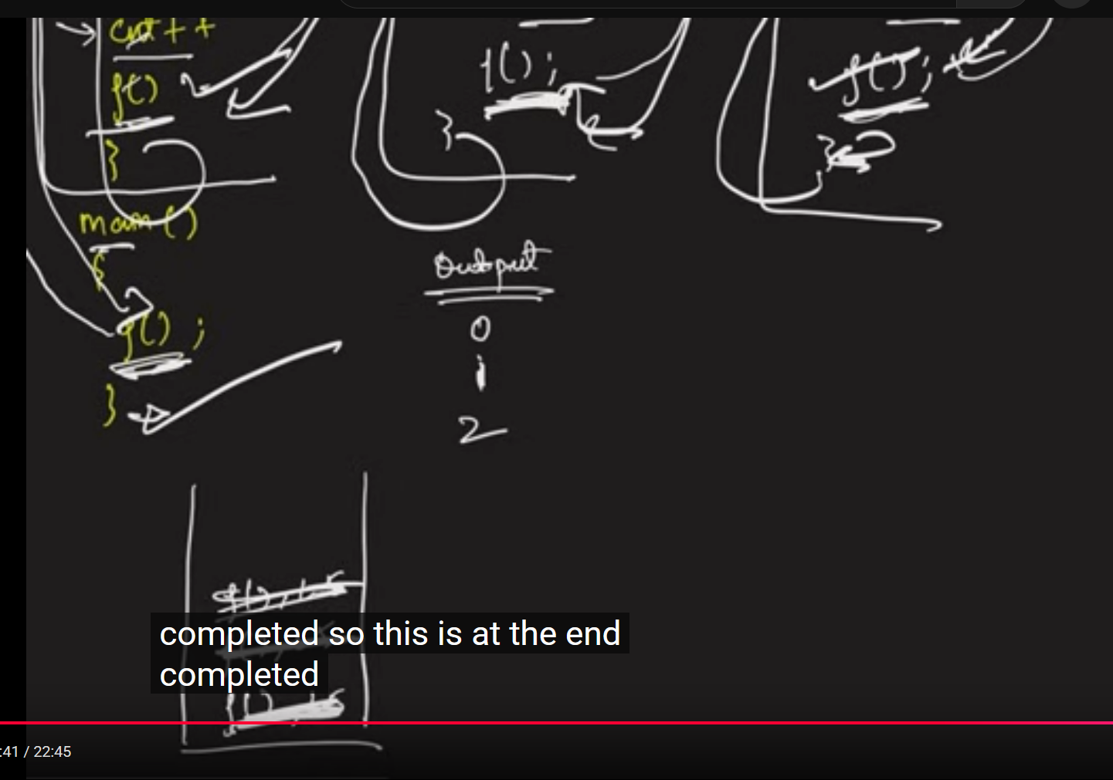

## **Recursion Tree**

To explain the tutor wrote the entire function again and again which is tedious. So the whole representation is truncated into a recursion tree. Instead of writing the entire function we represented it in terms of its name i.e., the entire function represented in smaller representation. This is called a Recursion Tree.

# **Stack Overflow Error**

A function is completed when the last line is successfully executed. But the above example has not been completely executed as the function called another function. As the stack has a particular memory space, it cannot keep on piling up all the incomplete function calls in the memory leading to memory becoming full. This is when segmentation fault happens. This is commonly known as Stack Overflow. Another definition is when there are numerous function calls waiting due to recursion is called Stack Overflow. This is why we don’t write a code which has infinite recursion calls as we end up with Stack Overflow.

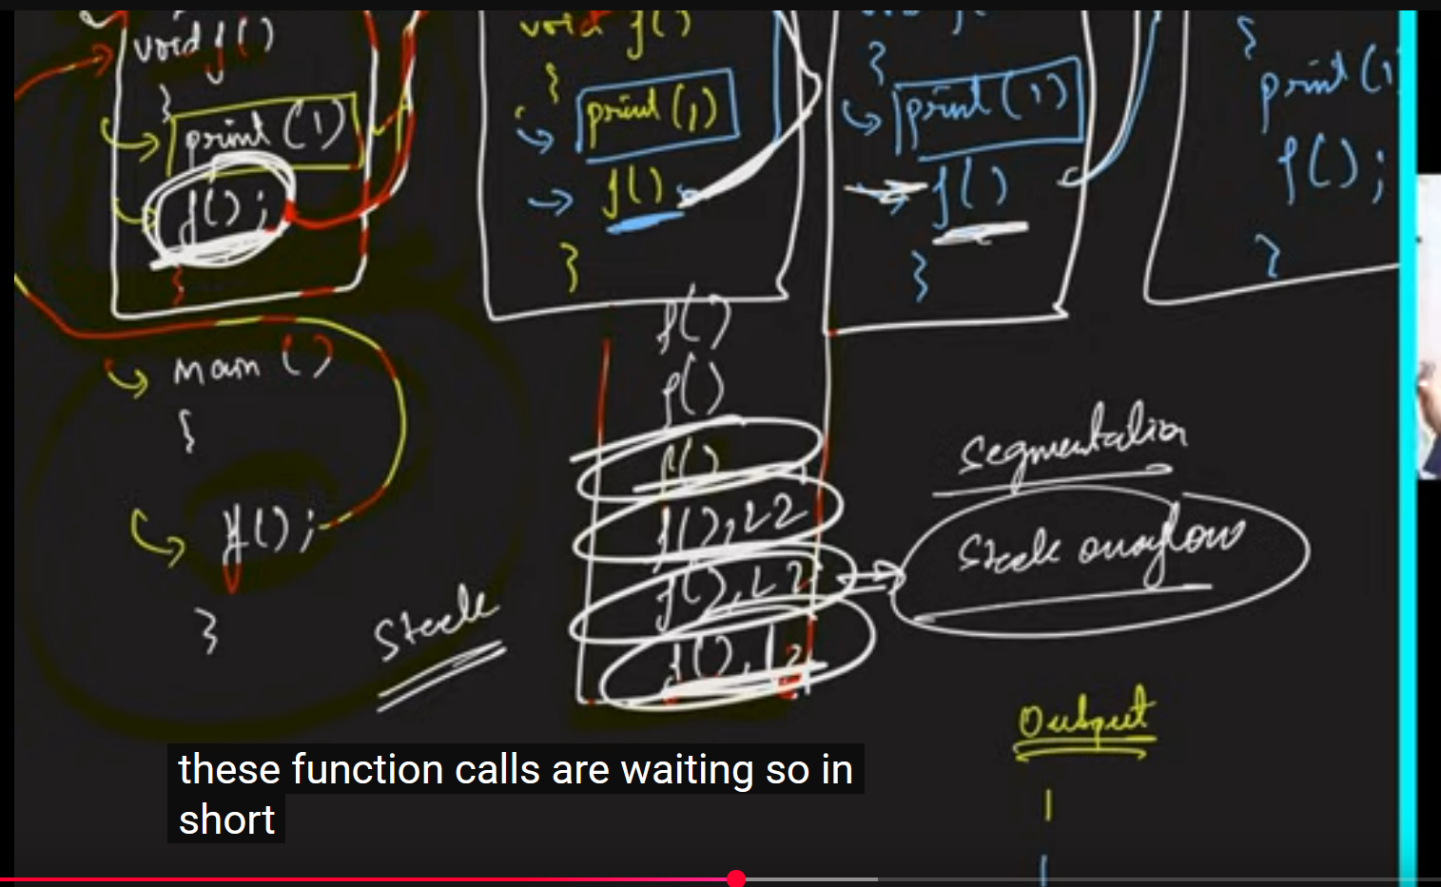

## **Stack Space (Auxiliary Space)**

The space where the remaining non-executed or not completed functions are stored. It is also called Auxiliary space.

# **Examples**

## Example-1: Printing name n times using recursion

Generic way is to use ‘for’ loop and print the name n times. Here solving using recursion way, we are going to use change of parameters concept.

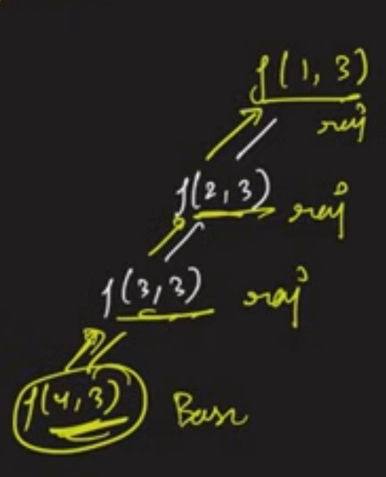

The time complexity is O(n) as we are calling n functions. The logic inside the function will take only O(1) times. For Space Complexity we assume the Stack Space is being used, it is O(n). This Space complexity being used here is hypothetical, we are not using array, we are using the computer’s internal memory which is the stack space.

## Example-2: Printing numbers from 1 to N using recursion

The implementation is similar to the previous problem only difference is we will print the number instead of the name.

## Example-3: Printing numbers from N to 1 using recursion

The implementation is similar to the previous problem the only differences are: -

* The base condition will be index < 1 instead of index < numberOfTimes.
* The method definition is printingName(int index) instead of printingName(int index, int numberOfTimes).

## Example-4: Printing the numbers from 1 to N by backtracking using recursion

Want to print from 1 to N numbers but should not use ‘i+1’ i.e., the recursion call starts from ‘(N, N)’. Will be understanding backtracking. Refer the code in the repository [AlgorithmsAndDataStructures](https://github.com/Phanindra08/AlgorithmsAndDataStructures) under the recursion package.

In order to print in ascending order, it is not mandatory that we start from 1. We can start from the back and we can print the number after the function call. By doing this we made sure that the last guy has been executed first. If the print statement is after the function call, then the print statement gets executed only if the base case is true.

**Recursion Tree for the above problem is:**

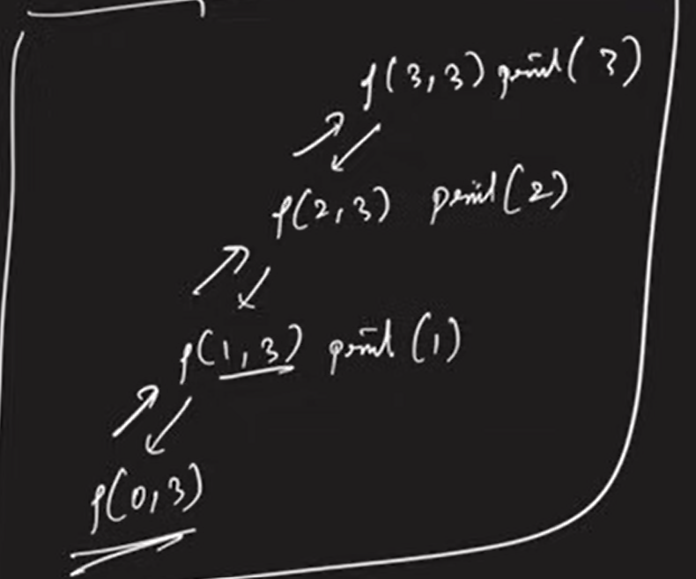

## Example-5: Printing the numbers from N to 1 by backtracking using recursion

Want to print from N to 1 numbers but should not use ‘i-1’ i.e., the recursion call starts from ‘(1, N)’. Will be understanding backtracking. Refer the code in the repository [AlgorithmsAndDataStructures](https://github.com/Phanindra08/AlgorithmsAndDataStructures) under the recursion package.

In order to print in descending order, it is not mandatory that we start from N. We can start from the 1 and we can print the number after the function call. By doing this we made sure that the last guy has been executed first. If the print statement is after the function call, then the print statement gets executed only if the base case is true.

## Example-6: Sum of first n numbers

The above problem can be solved using simple for loop but here we solve it using recursion. Will solve it in 2 ways: - parameterized way (Solve it using parameter) and the functional way (the function returns the answer).

### Recursion Tree for Parameterized Way

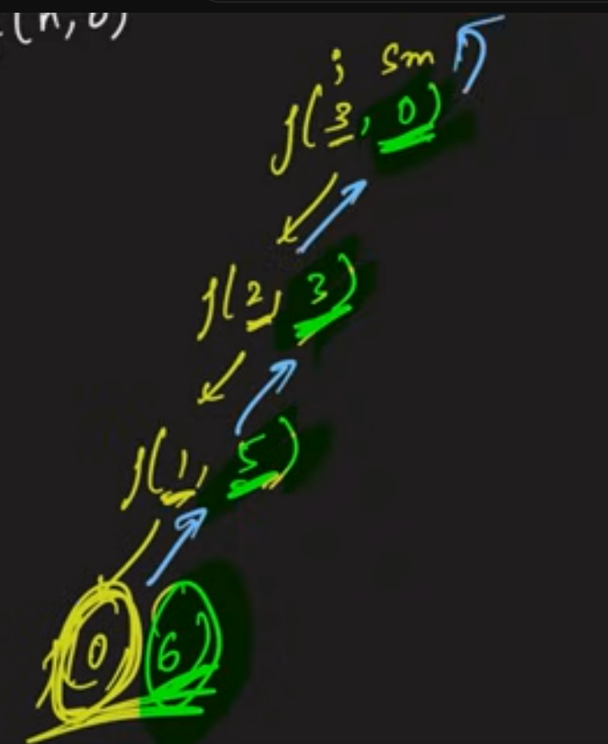

### Functional Way

Refer the code in the repository [AlgorithmsAndDataStructures](https://github.com/Phanindra08/AlgorithmsAndDataStructures) under the recursion package.

The time complexity for the above problem is O(n). As we don’t take a lot of time inside these functions the number of function calls is equal to the time complexity for the function.

The space complexity there will be ‘n’ number of functions waiting in the stack to be completed. So it is the stack space.

## Example-7: Factorial of a number

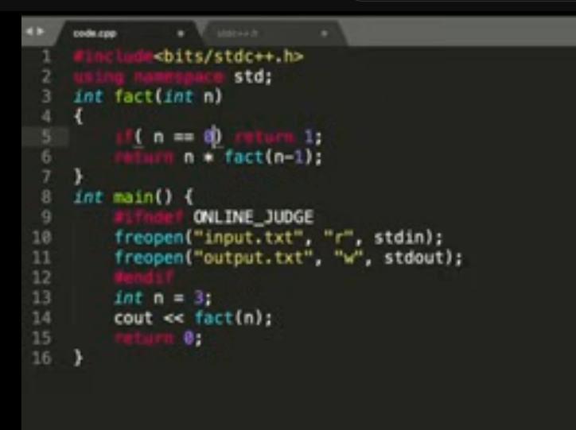

# **Dynamic Programming**

There are two ways people tend to solve it.

1. **Tabulation Way: -** Bottom-up Dynamic Programming. Bottom-up doesn’t mean we are going to start from zero till top. It can be vice versa as well. But as the name suggests it is a bottom up approach of solving the problem.
2. **Memoization Way: -** Top-down Dynamic Programming. Top-down doesn’t mean we are going to start from top till zero. It can be vice versa as well, depends on our implementation skills. But as the name suggests it is a bottom up approach of solving the problem.